**PROJECT REPORT TEMLATE**

1. **INTRODUCTION**

**1.1 over view**

The "Designing Professional Business Cards for Effective Networking" project focuses on creating visually appealing and impactful business cards that leave a lasting impression and facilitate meaningful connections in the business world. A well-designed business card is an essential tool for networking, showcasing professionalism, and conveying key information succinctly.

1.2 Purpose

* Small and Convenient
* Affordable Advertisement
* Give A visual aid to Remember your business
* Business cards are a vital networking tool
* Business Cards Create and professinal Image credible

# Problem Definition & Design Thinking

* 1. **Empathy Map**

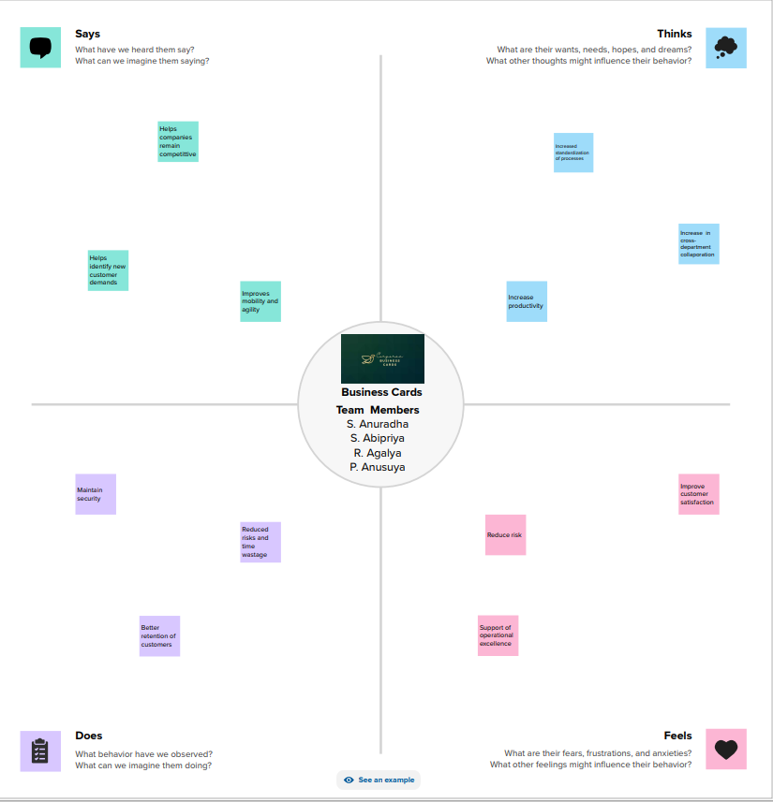

# Ideation & Brainstorming Map

# 

1. **RESULT**

** Business Card**

1. **ADVANTAGES & DISADVANTAGES**

**ADVANTAGES**

* Canva is very simple to use and user friendly
* Canva provides social media templates
* Canva offers a professional look
* Team access
* As well as million of image

**DISADVANTAGES**

* The free version is limited
* Unique elements cannot be created
* limited export setting s
* Alignment concerns
* Unable to move one design to another design

**APPLICATIONS**

* We create a canva account
* Choose our design type
* And we used business card template
* we uploaded our backround image
* we used uploading photos, and adding text, and used to editing elements ,and change fonts
* Added to the women icon , flower design of corner.
* we created to business card
* Finally we downloaded a design

**CONCLUSION**

People in our team worked together to make a business card on the topic " Designing professional business card " through this , a company's advertisement can be brought to the door of the card . canva is an essential tool for most business .It is easy to use offers a wide range of templates, its affordable, customizable and helps business with their branding. Graphic designing can be learned through this project.